**Dublin Bill Management Company – A Guide**

Thank you for purchasing our system! This guide will talk you through how to use it and aim to solve any problems you may encounter, along with some frequently asked questions.

The aim of this system is to read, store and produce reports on bills.

**Main Menu**

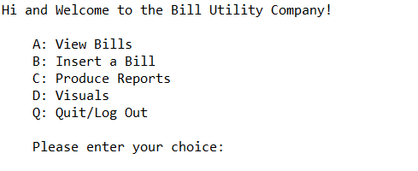Once launched, you will see the below menu:

Using your keyboard; make a selection on the available options. If you select a letter not listed or type the wrong letter by accident, you will see the following message and be prompted to select again;

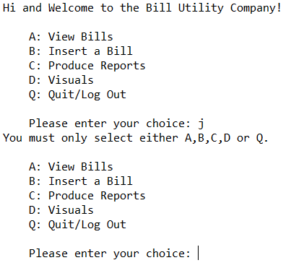

**View Bills**

The first option is view bills. Enter ‘a’ to access this screen.

This option will return a list of all bills currently in the system. Below is the screen you will be presented with. Column headings have been added for reference. Any subsequent bills added will also appear here when option A is reselected.

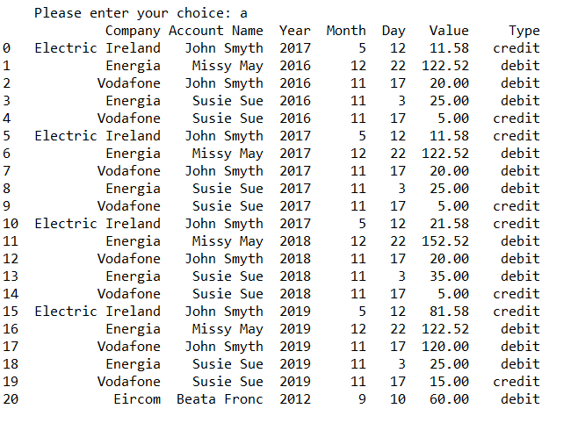

**Insert a Bill**

As well as viewing bills, the system allows for new bills to be added to the existing dataset. This can be accessed via option B on the main menu.

Once selected, it will ask the user for each item of information separately (see below):

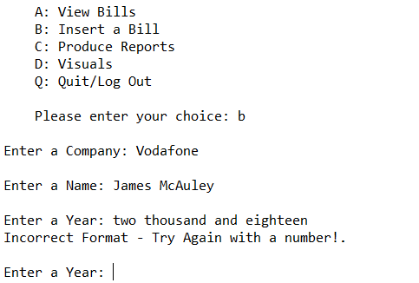

The first two pieces asked for are ‘Company’ and ‘Name’. The third piece is the ‘Year’. If the year entered is qualitative, the above error message will appear, and the user will be asked to re-enter the year. Similarly, the system also only allows for bills dated 2000 and later, and 2020 or before. If a year outside of this range is entered, it will not be accepted (see below) and the user will have to try again. 2018 is acceptable.

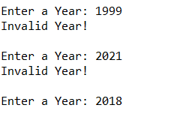

Next item to enter is the ‘Month’. Similar to year, it will only accept a numeric input, between 1 and 12.

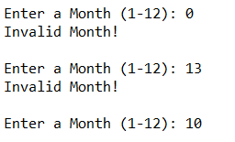

Last item in the date category is ‘Day’. This requires a numeric input between 1 and 31. 10 is acceptable.

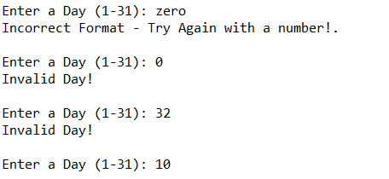

The next item asked for is bill amount. This is a float type, so the system accepts decimal places. The last item is bill type, and the user is asked to enter either debit or credit. Once all has been submitted, a message will appear confirming the bill has been added (see next page).

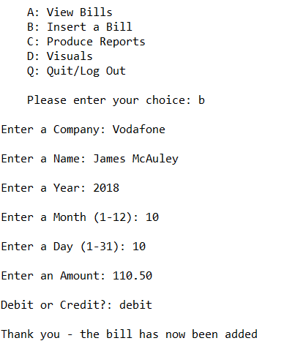

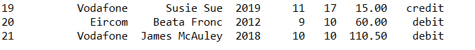If option A (view bills) on the main menu is selected again, the newly added bill can seen at the bottom of the list on line 21 (below). It is also added to the csv Masterfile.

**Produce Reports**

The system also allows for a range of reports to be generated, based on the stored bills data.

The following is a list of reports available, again in a menu for easy selection.

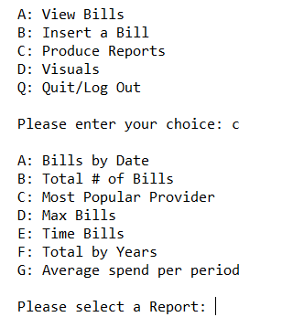

1. *Bills by Date*

This option will display the full list of reports in date order, starting with the oldest first, through to the newest (note the newly added bill is in the list below – 10/10/2018)

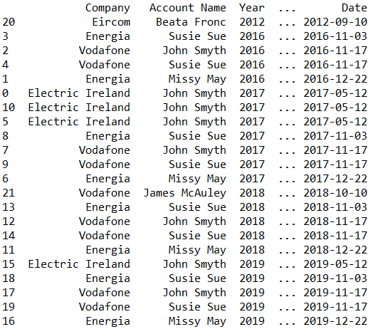

1. *Total # of Bills*

Option B will return the total number of bills stored on the system (the first bill is considered 0 – so despite the list above showing 21, there are in fact 22)

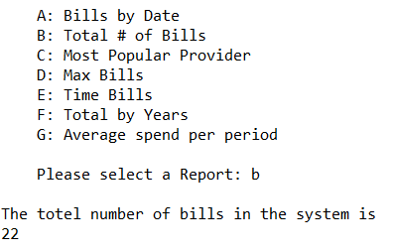

1. *Most Popular Provider*

The system will also return the most frequently used company. In this case, based on the current bills, the most popular is Vodafone.

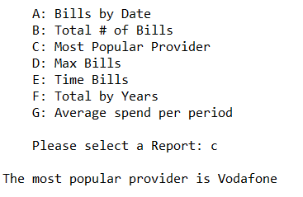

1. *Max Debit and Credit Bills*

The D option will return the highest bill currently in the system, for the two types of bill; debit and credit. This will change if a new higher bill is submitted.

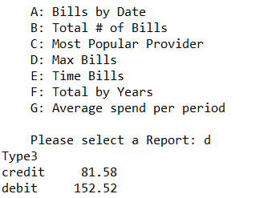

1. *Time Bills*
2. *Total by Years*

Option F will return both the credit and debit total bills for each year. 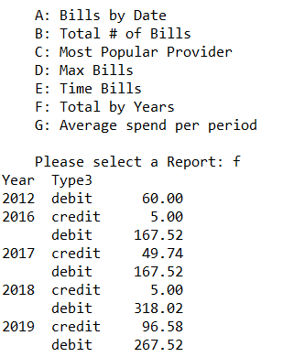

1. *Average spend per Period*

This report will ask the user to select a month and a year, and it will then show the average of the bills for that particular period.

